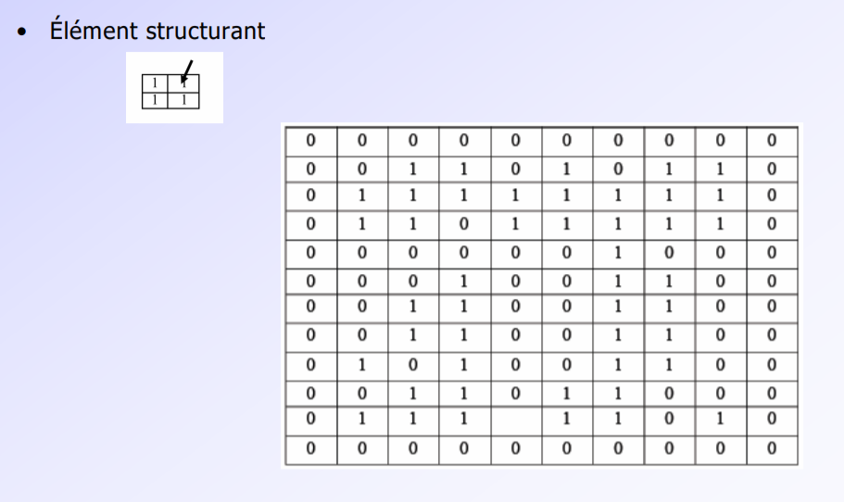

|  |  |  |
| --- | --- | --- |
| 0 | 1 | 1 |
| 0 | 1 | 1 |
| 0 | 0 | 0 |



|  |  |  |
| --- | --- | --- |
| 1 | 1 | 0 |
| 1 | 1 | 0 |
| 1 | 1 | 0 |

